Type the Title of Your Commentary, Capitalize First Letter
Author
First affiliation, Address, City and Postcode, Country
http://yourorganization.web.page

Online: 12 Dec 20xx |  | Commentary to “BMDJ paper” OR Authors’ response OR Review of “Book title” OR Presentation of “Project / Conference / Repository / …”  Creative Commons BY-NC-SA 4.0  © 2015 Hosting by Procon Ltd. All rights reserved.

1. Main Text
Commentaries are shorter articles, usually 3 to 5 pages (and no more than ten pages of length) and present an original critique on a paper, published in the Biomedical Data Journal and the authors’ response to such a critique.
This section of the journal may include book reviews, presentation of research conducted by others, summary and findings of a workshop or a conference, presentation of a project or a data repository relevant to the journal.
The structure of a commentary is not fixed. Shorter paper may not even have subtitles.
Further instructions for authors are the same as for a policy or modelling paper, presented in brief below.

Spelling
Authors from the United States are welcome to use U.S. spelling. All other authors, please use consistently U.K. spelling.
For referenced sources, use the title as given in the original publication.

1.1 Structure
Files must be in MS Word only and should be formatted for direct printing, using the MS Word template provided. Figures and tables should be embedded and not supplied separately.
Place acknowledgements in a separate section at the end of the article and do not include them on the title page, as a footnote to the title or otherwise.
Bulleted lists may be included and should look like this:
- First point
- Second point
- And so on
- Last bullet point.
Page numbers will be added by the publisher.

1.2. Tables
All tables should be numbered with Arabic numerals. Every table should have a caption. Headings should be placed above tables, left justified. Only horizontal lines should be used within a table, to distinguish the column headings from the body of the table, and immediately above and below the table. Tables must be embedded into the text and not supplied separately. Below is an example which the authors may find useful.
If the table is too large to fit within the column, create a new section by inserting two continuous section breaks and select one-column layout for this section.
Table 1. An example of a table.
An example of a column heading | Column A (t) | Column B (t)
And an entry | 1 | 2
And another entry | 3 | 4
And another entry | 5 | 6

1.3. Charts, figures, photos
All figures should be numbered with Arabic numerals (1,2,3,….). Every figure should have a caption. All photographs, schemas, graphs and diagrams are to be referred to as figures. Line drawings should be good quality scans or true electronic output. Low-quality scans are not acceptable. Figures must be embedded into the text and not supplied separately. Lettering and symbols should be clearly defined either in the caption or in a legend provided as part of the figure. Figures should be placed at the top or bottom of a page wherever possible, as close as possible to the first reference to them in the paper.
The figure number and caption should be typed below the illustration in 10 pts and left justified. Artwork has no text along the side of it in the main body of the text.

Figure 1: Sample illustration.
If a chart or an image is too large to fit within the column, create a new section by inserting two continuous section breaks and select one-column layout for this new section. See the example below.

1.4. Construction of references
Use endnotes to cite a source in the text. Thus, references are numbered consecutively in the list at the end of the article in the order they are cited in the text. Use font size 10 pts and single-spaced paragraphs.
Use one endnote for each referenced source. If you want to cite more than one source in support of your point, separate endnote marks by a coma.,

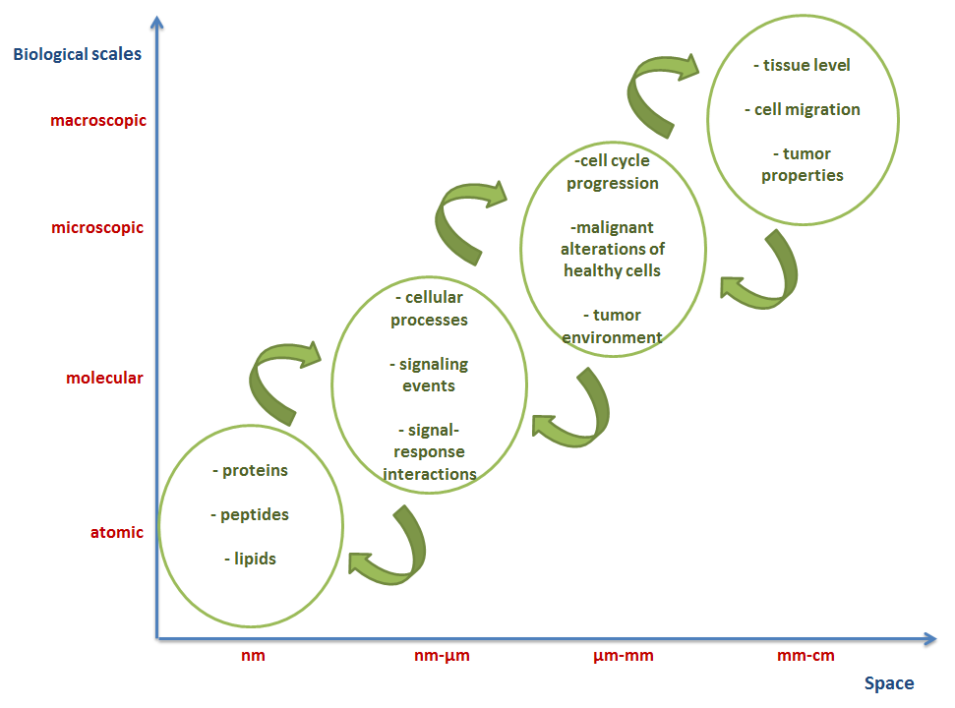
Figure 2: Illustration of the biological scales for computational cancer models including atomic, molecular, microscopic and macroscopic.

For the referenced sources BMDJ applies the Style Guide of the US National Library of Medicine (NLM). Please consult the NLM Style Guide, http://www.nlm.nih.gov/citingmedicine. A short guide on the main types of references is available at http://www.biomed-data.eu/content/style.
At the end include the DOI number of the cited source, include its DOI number. If a DOI is not available, include its PubMed Identifier (PMID).
Most papers in the biomedical field will have at least one of these identifiers assigned. If you wish to cite a paper, a book, a report or an official document that does not have a DOI or PMID assigned, please include the most recent working URL to the source.

1.5. References to datasets
Data citations provide bibliographic information for the data records described in the manuscript. These should be in the format “Lastname1 Initial(s)1, Lastname2 Initial(s)2, Lastname3 Initial(s)3. Repository_name Dataset_accession_number or DOI (Year).”
In the text of the paper refer to a dataset placing its number in parentheses (Data Citation 1). You can use either the dataset accession number or its DOI (Data Citation 2).

1.6. Footnotes
Footnotes should be avoided

2. License
Authors who publish with BMDJ will retain all intellectual property rights, including moral rights in their work. Data papers/metadata accompanying the research data, including the abstract describing the research data, will be licensed to the public under “Creative Commons 4.0 Attribution-NonCommercial-ShareAlike” International license (CC BY-NC-SA 4.0).

3. Conclusions
Once accepted and ready for online publication, the publisher will insert page numbers and assign a DOI to your paper.

Acknowledgements
Acknowledgements and Reference heading should be left justified, bold, with the first letter capitalized but have no numbers. Text below continues as normal.

Data Citations
¹ Finlayson SG, LePendu P, Shah NH. Dryad http://dx.doi.org/10.5061/dryad.jp917 (2014).
² Baric R, Katze M, Chang J, Gralinski L, Law L. Gene Expression Omnibus GSE37569 (2012).

References

Lindert S, Li MX, Sykes BD, McCammon JA. Computer-Aided Drug Discovery Approach Finds Calcium Sensitizer of Cardiac Troponin. Chem Biol Drug Des. 2014 Jun 20. DOI: 10.1111/cbdd.12381.
Silva, L. PLOS’ New Data Policy: Public Access to Data. 24 February 2014. Available at www.plos.org/ plos-data-policy-faq.
Zhang P, Brusic V. Mathematical modeling for novel cancer drug discovery and development. Expert Opin Drug Discov. 2014 Jul 25: 1-18. DOI: 10.1517/174604 41.2014.941351.
Lawrence B, Jones C, Matthews B, et al. Citation and peer review of data: Moving towards formal data publication. Int J Digital Curation. 2011;6(2):4–37. DOI: 10.2218/ijdc.v6i2.205.
Bunevicius A. The Need for Open-access, Structured Data in Clinical Brain Research. Biomedical Data Journal. 2015;1(1):27-32. DOI: 10.11610/bmdj.01104.
Kourou K, Fotiadis DI. Computational Modelling in Cancer: Methods and Applications. Biomed Data J. 2015;1(1):15-25. DOI: 10.11610/bmdj.01103.
Pantos C, Schroeder M, Ivanova P. Open Access to Quality Biomedical Experimental and Clinical Data and Data-based Models. Biomed Data J. 2015;1(1):01-02. DOI: 10.11610/bmdj.01101.
Guedj D, Ramjoué C. European Commission Policy on Open-Access to Scientific Publications and Research Data in Horizon 2020. Biomed Data J. 2015;1(1):11-14. DOI: 10.11610/bmdj.01102.

